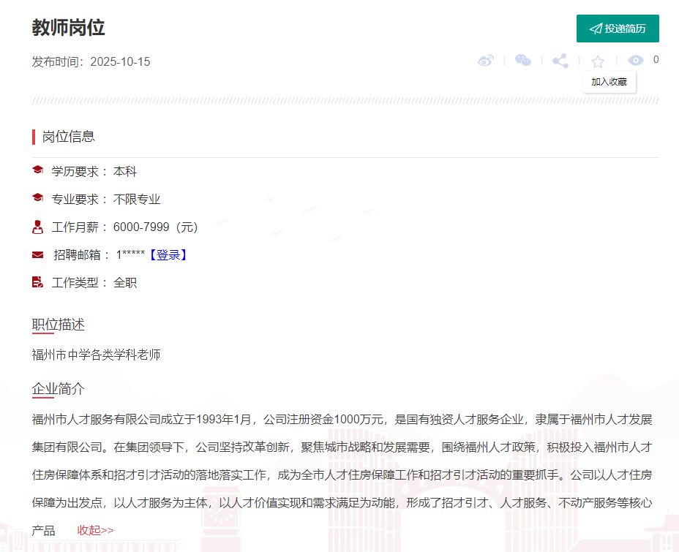  
  
>>点击进入后登陆：**[投递简历](https://career.ecnu.edu.cn/career/zwxx/view/AsWTdcQpDp7A6sgZrDzyZ?refType=indexXjhxx&refId=118658752860786688)**