附件5

[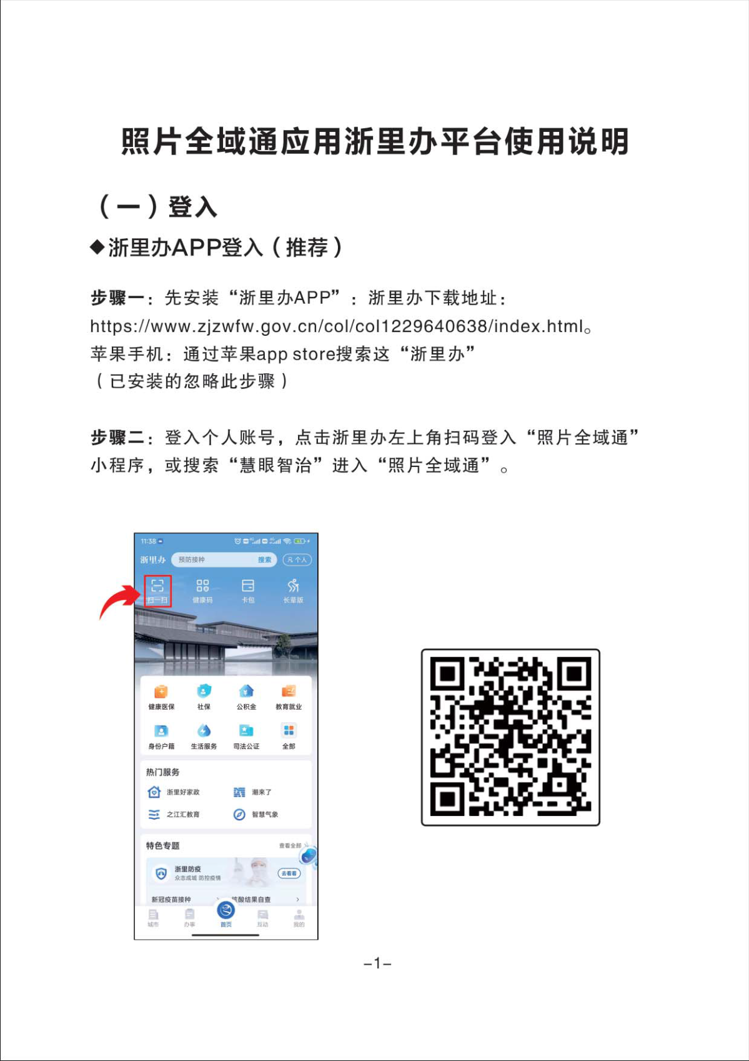](http://www.jiashan.gov.cn/picture/0/70307d8c31d94c49ad2bc587c604145a.png)

[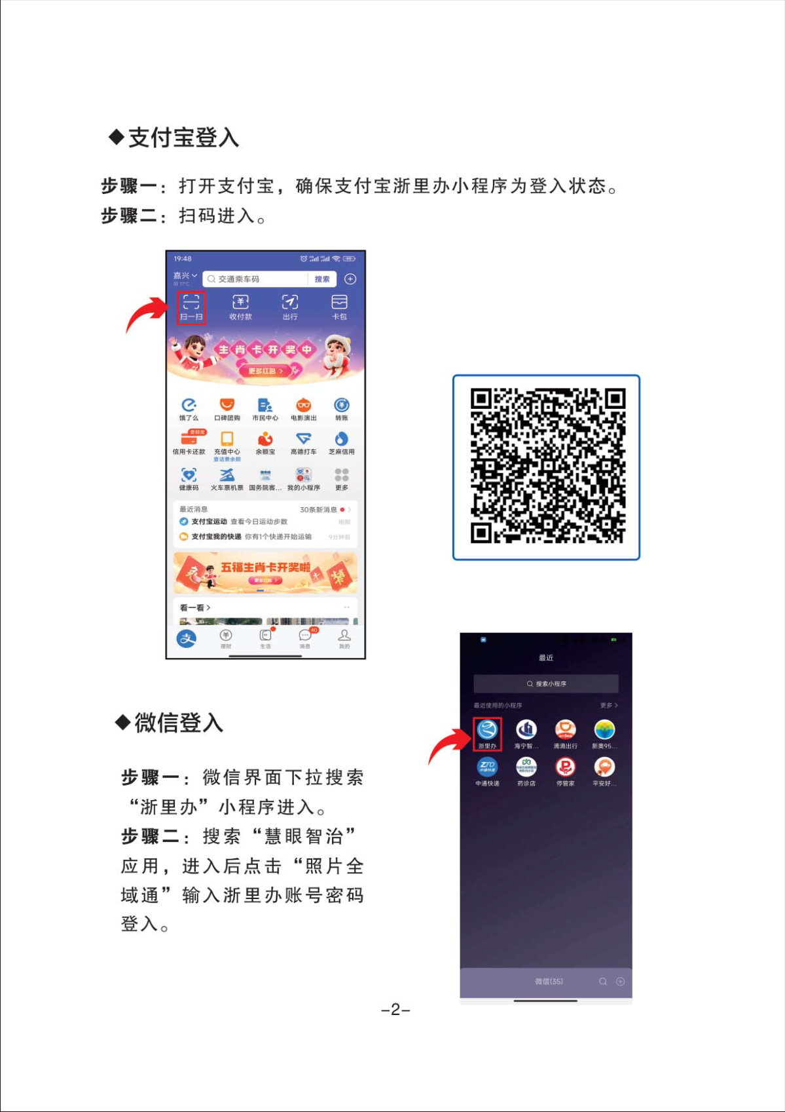](http://www.jiashan.gov.cn/picture/0/389be6960be04fde8da3ed9d0e19ace7.png)

[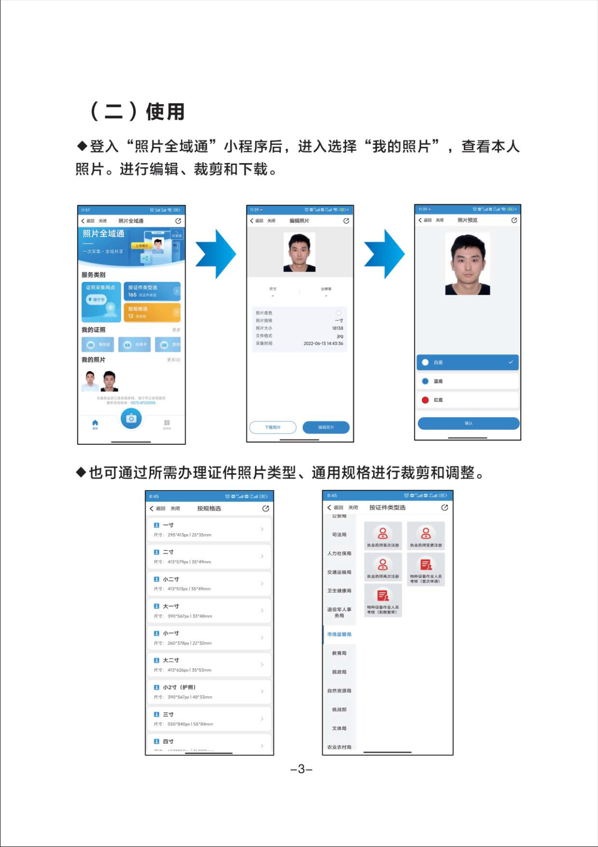](http://www.jiashan.gov.cn/picture/0/806c157ca601405fad4b51fe7e898c87.png)

[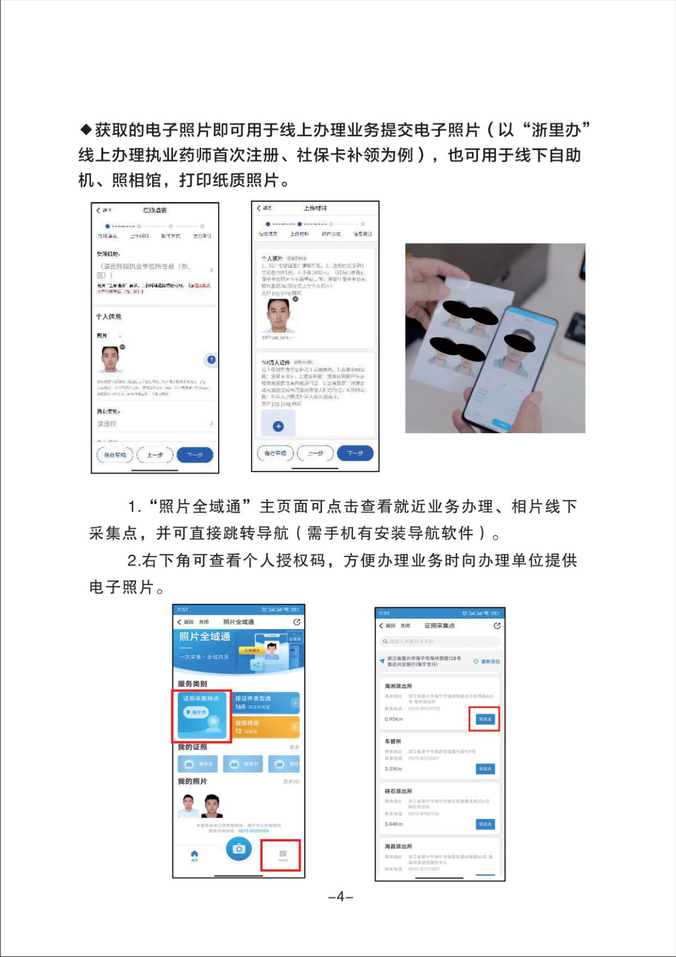](http://www.jiashan.gov.cn/picture/0/2f821700714a4c7890398ec3fb99f23e.png)

[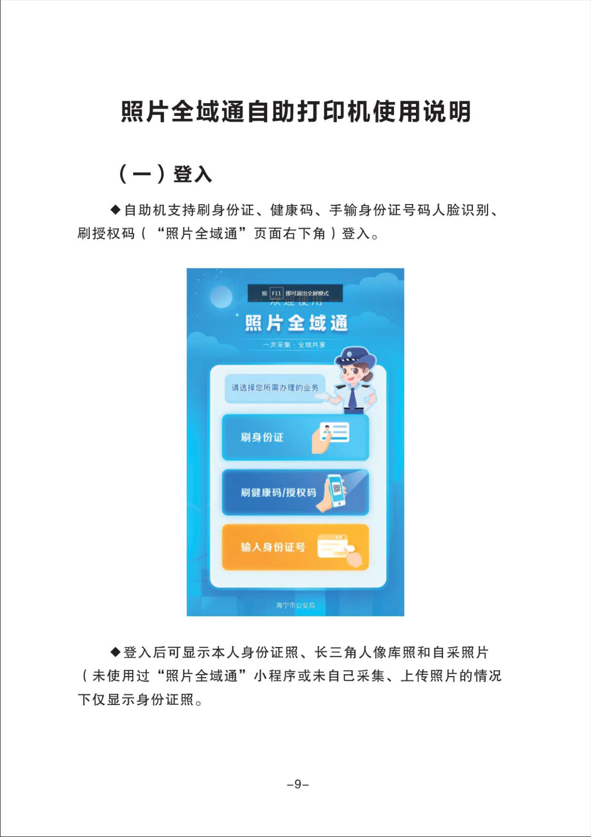](http://www.jiashan.gov.cn/picture/0/5e3dfa6260744cbdb2ff69cca2d56d26.png)

[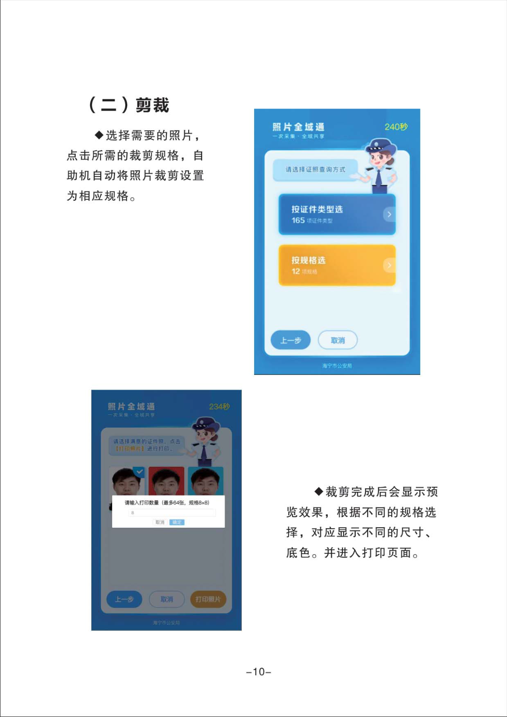](http://www.jiashan.gov.cn/picture/0/876e8af613cd45128f02009edae6928d.png)

[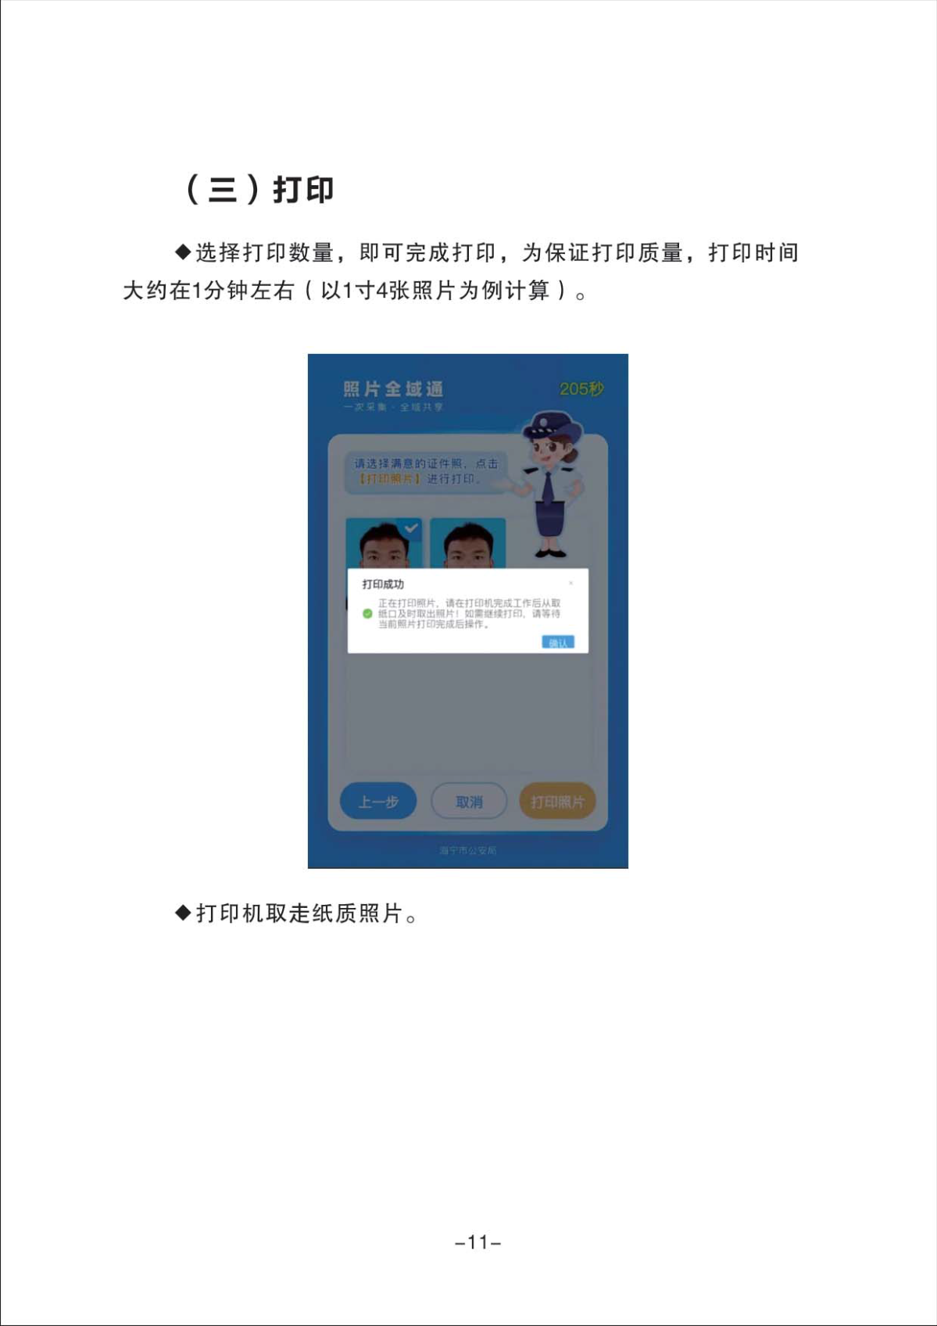](http://www.jiashan.gov.cn/picture/0/3dfcbe1906a14ed787e7b994ab25e1f9.png)